1. The diagram below represents a cross section of four sedimentary rock layers containing fossil remains. The layers have not been overturned.
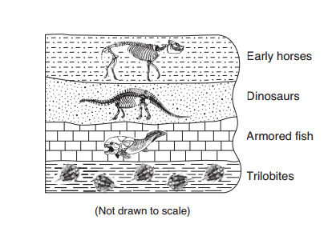

Which type of fossil is found in the most recently formed sedimentary rock layer?
(1) early horses (2) armored fish (3) dinosaurs (4) trilobites

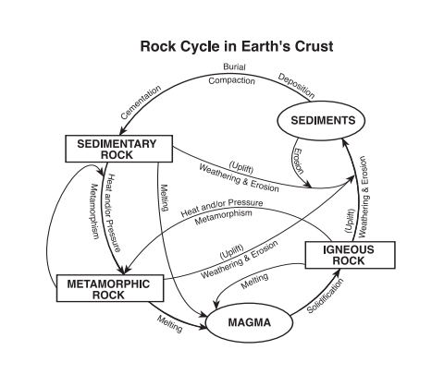
2. The diagram below illustrates the rock cycle in Earth’s crust.

According to the diagram, what will form when sedimentary rock is exposed to heat and/or pressure?
(1) magma (2) igneous rock (3) sediments (4) metamorphic rock

