Convection Currents
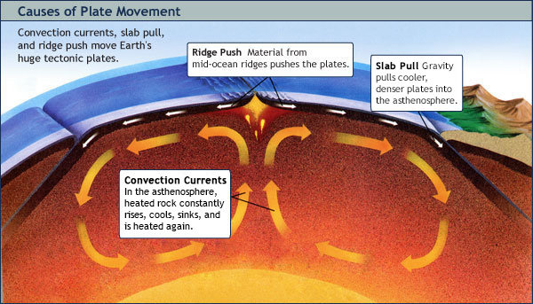
Tectonic plates rest on the asthenosphere. This is a layer of soft, hot rock. The heat that drives these convection currents comes from the core. Rock in this layer moves by convection. This is also true of rock in the mantle just below it. The hot, soft rock rises. It cools and sinks. It is heated and rises again. This sinking and rising motion is convection. If the motion keeps going, it is called a convection current. Convection current is a motion that transfers heat energy in a material.
Convection currents in the mantle’s rocks are slow. This makes the rock in the mantle creep very slowly. It creeps only a few centimeters a year. Look at the diagram. It shows convection currents circulating. The tectonic plates in the lithosphere are carried on the asthenosphere. Convection currents carry the plates thousands of kilometers. This happens over millions of years.
Scientists suspect that two other motions help move these huge plates. One is slab pull. The other is ridge push.
- Slab pull happens because of gravity. Gravity pulls the edge of a cool, dense plate into the asthenosphere. You can see this in the diagram. The entire plate is dragged along. This is because plates are rigid.
- Ridge push happens when material from a mid-ocean ridge slides downhill. It slides down from the ridge. It pushes the rest of the plate.

