Convection Currents in the Mantle

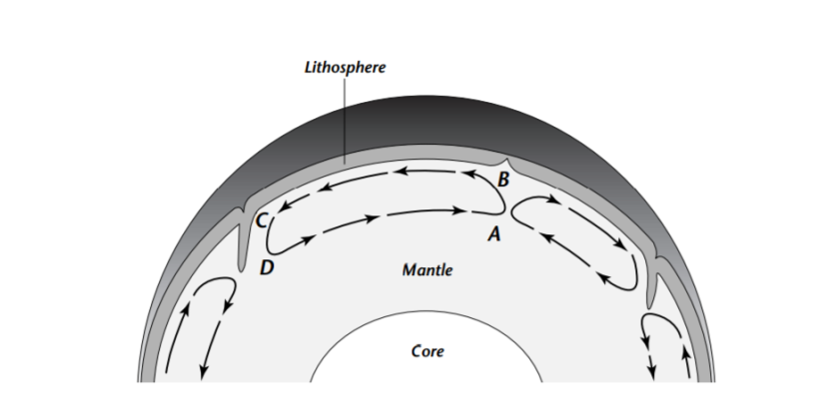
1. Color the diagram below. Use RED for hot material and BLUE for cool material.

2. Where does the heat come from that drives this convection current in the mantle?

_______________________________________________________________________________________________________________________________________________________________________________________________________________

3. What causes the convection currents to turn down at point C? _____________________________________________________________________

4. Where is the temperature of the mantle greater, at point A or point B? Explain why.
____________________________________________________________________________________________________________________________________________________________________________________________________________________________________________________________________________________________________________________________________________________________________________________________________________________________

5. Where is the density of the mantle greater, at point B or point C? Explain why. _________________________________________________________________________________________________________________________________________________________________________________________________________________________________________________________________________________________________________________________________________________________
6. Predict how this convection current will affect the crust material above it.

____________________________________________________________________________________________________________________________________________________________________________________________________________________________________________________________________________________

