Plate Boundary Zones Article
(Ever-Changing Earth pg. 224-234)

Subduction Zones
Remember that a convergent boundary is one in which two plates are moving toward each other. What happens when plates converge depends on the type of crust that the plate edges are made of. A plate interaction in which two plates converge can involve two oceanic plates, or one continental and one oceanic plate. The interactions that occur between different kinds of plates result in different geologic activity and the formation of different Earth structures.

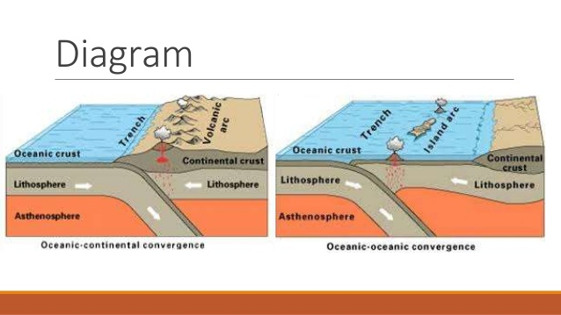
Oceanic crust is more dense than continental crust. When oceanic crust and continental crust converge, the more dense oceanic crust moves under the continental crust. This causes a subduction zone. A subduction zone can also occur between two oceanic plates. Along the subduction zone, a new structure is formed. The sides of the structure tend to be very steep, with a deep depression that runs along the length of the boundary between the plates. An earth structure that is formed when an oceanic plate moves under another plate is called a trench.

Buckling Zones
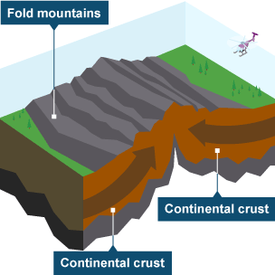
Remember that a convergent boundary is one in which two plates are moving toward each other What happens when plates converge depends on the type of crust that the plates are made of. A convergent plate interaction can involve two oceanic plates or one continental plate and one oceanic plate. The interactions that occur between different kinds of plates result in different geologic activity and the formation of different Earth structures.
Buckling zones are regions along convergent plate boundaries where two continental plates of equal density converge. As the two plates slowly collide, the enormous force causes rocks at the edges of the plate s to buckle. The edges of these plates thicken and push upward, forming large, folded mountain ranges. Some of the largest and highest mountain ranges in the world were created in this way. Some mountain ranges, such as the Himalayas, are still being pushed up today as the plates involved continue to collide.

Rift Zones
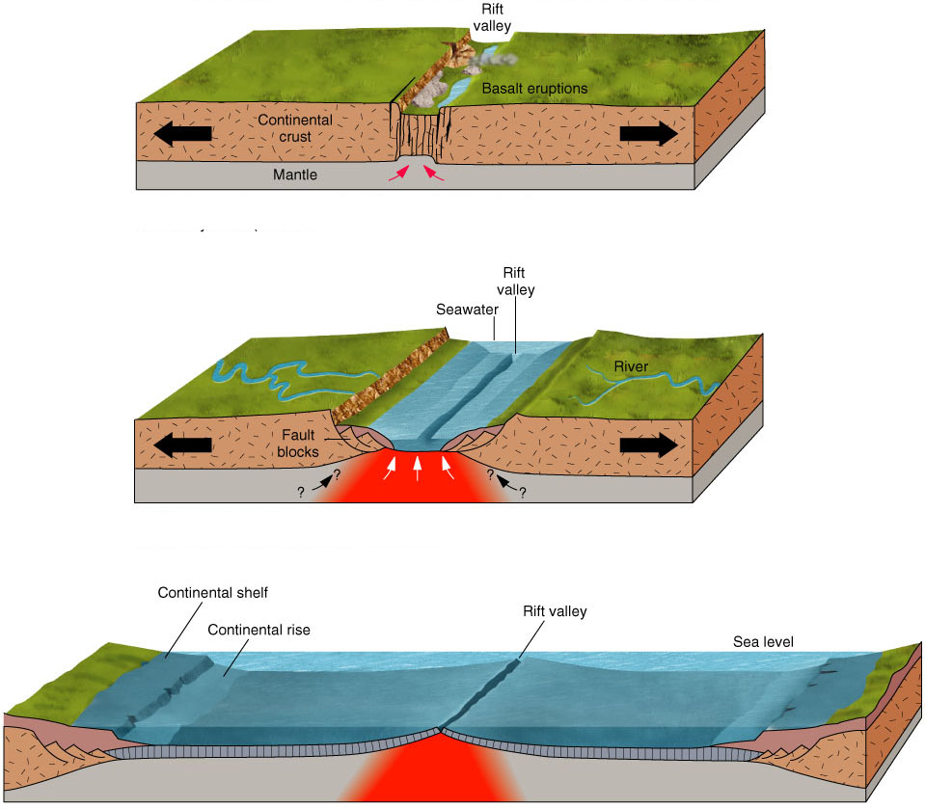
A divergent boundary is a region where two plates are spreading away from each other. Diverging plates move away from each other very slowly as a result of the movement of mantle material underneath. As plates move apart, magma rises from the mantle. It pushes up the crust at the edges of the plates, eventually breaking through the plate boundary and creating new crust at the point where the plates pulled apart.

At divergent boundaries, convection currents in the mantle are constantly pulling the two plates away from each other. This means that the mantle material coming to the surface does not have much time to build up and harden before the material that was just laid down is pulled along with one or both of the plates. When mantle material rises out of a divergent boundary as plates are continuing to move apart, volcanic mountains are built.
When a divergent boundary occurs beneath continental crust, rifting or surface cracking occurs. Faults form on either side of the rift and the thin crust between the spreading plates sinks to form a valley between two mountain ranges. These are called rift valleys. As the two plates continue to diverge, a rift valley can sink so low that it is below sea level. This causes new oceans to form.

