- A group of science students have been learning how the human circulatory system reacts during exercise. The students measured their heart rates both before and after they ran five laps around the school gym. This was repeated two more times, with a 5-minute rest period between each trial. The average heart rates of the students are shown in the bar graph.
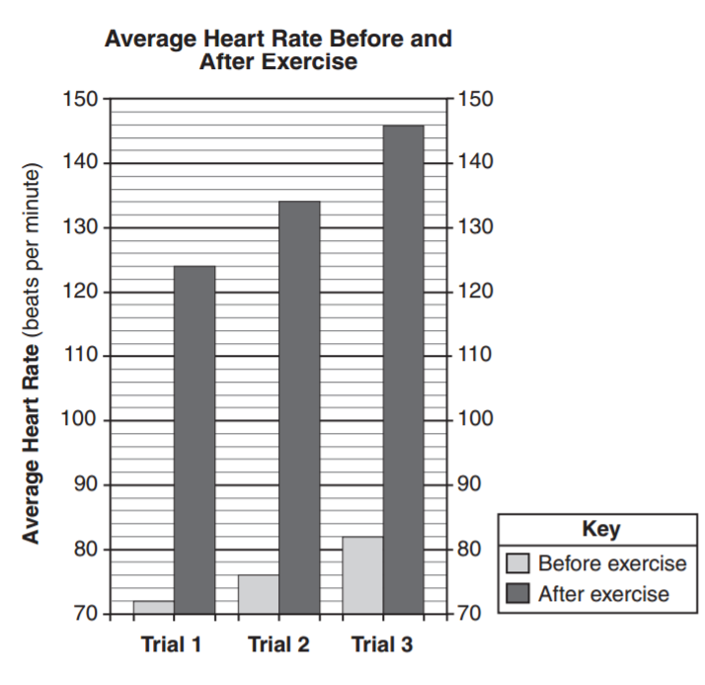

Use the data from the bar graph to complete the data table below [1]
